**COMP 1003: Worksheet1 Solutions**

If you need any further clarification about any of these solutions, please talk to your tutor in the practical.

**1.** What is 2/3 when expressed as a decimal (rounded to 3 decimal places)?

a. 2.333

b. 5.000

c. 0.667

d. 0.750

e. 1.333

**2.** If x=2/3 what is the value x+1?

a. 4/3

b. 5/3

c. 3/2

d. 5/4

e. 3/3

**3.** If x=2/3 what is the value of 2*x? (2 times x)

a. 4/3

b. 4/6

c. 2/6

d. 2

e. 3

**4.** If x=2/3 and y=4/7, what is the value x+y?

a. 8/21

b. 8/7

c. 6/10

d. 26/21

e. 8/10

**5.** If x=2/3 and y=4/7, what is the value x*y? (x times y)

a. 8/21

b. 14/12

c. 12/14

d. 21/8

e. 26/21

**6.** If x=2/3 and y=4/7, what is the value x/y? (x divided by y)

a. 8/21

b. 7/6

c. 6/7

d. 21/8

e. 6/10

**7.** If x=3 and y=4, what is the value x*(y+2)? Ans=18

If x is a number, then “x-squared” is denoted by x2 and equals x2 = x*x (x times x).

**8.** If x=3, what is the value of (x2 - 3)/2?

a. 9

b. 1.5

c. 3

d. 1

e. 2

**9.** Using distributivity, decide which of the following expressions is equal to x*(y+2x)?

a. xy + x2

b. y + 2x2

c. xy + 2x2

d. x*y*2x

e. 3x2

**10.** Which of the following expressions is equal to 9xy + 3x2?

a. 12xy

b. 12yx2

c. 3x(3y+x)

d. 3x(y+x)

e. x(9y+3)

For the purposes of this module, a *function* f takes each number x and produces a new number f(x). For example if f is defined by the equation f(x) = x2 then f(1) = 1; f(2) = 4; f(3) = 9; f(3.5) = 12.25 … etc, etc.

**11.** If f(x) = x2, what happens to the value of f as x gets larger and larger?

a. f gets larger and larger

b. f gets smaller and smaller

If b = a2, then a is a square root of b. So for example 32 = 9, and therefore 3 is a square root of 9. (As an aside, -3 is also a square root of 9, but we won’t need to bother with “negative roots”.)

**12.** If x=64, what is the square root of x?

a. 8

b. 4

c. 16

d. 1

e. 2

If x is a number, then “x-cubed” is denoted by x3 and equals x3 = x*x*x (x times x times x).

**13.** If x=3, what is the value of x3 + 2x?

a. 27

b. 6

c. 35

d. 31

e. 56

**14.** If f(x) = 1/x, what happens to the value of f as x gets larger and larger?

a. f gets larger and larger

b. f gets smaller and smaller

**15.** What is 30% of 200?

a. 30

b. 100

c. 120

d. 60

e. 45

**16.** If 2x + 3y = 26, and x=4, what is the value of y?

a. y=1

b. y=3

c. y=5

d. y=7

e. y=6

**17.** If x2 + y2 = 25, and y=3, what is the value of x?

a. x=1

b. x=3

c. x=4

d. x=6

e. x=7

Given a function f, we can plot the graph[1] of f: for example if f(x) = x2 then the graph of f is show below. (You can try out a few values and check it out.)

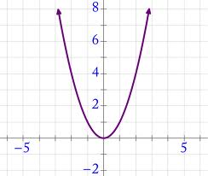

x

The slope of a curve y = f(x) is *positive* if the value of y increases as x increases. So for example the above curve has a negative slope when x<0 and a positive slope when x>0.

**18.** Is the slope of the graph below positive or negative?

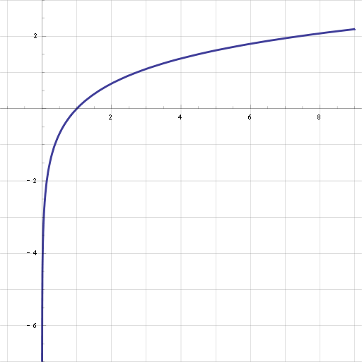

a. positive b. negative c. sometimes positive and sometimes negative

**19.** Is the slope of the graph below positive or negative?

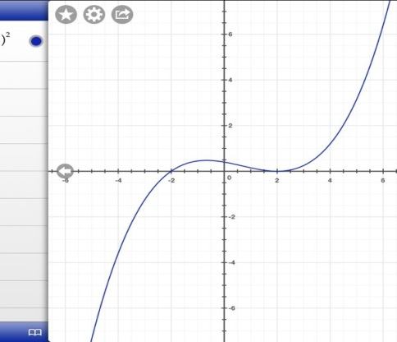

a. positive b. negative c. sometimes positive and sometimes negative

1. We’d sometimes refer to a graph as a curve